Presentation Primary School, Clonmel.

Discover Primary

Science and Maths 2018

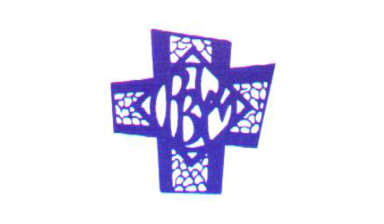

Log of Evidence

TP001

Step 1 Science

DPSM PLAQUE OF STEM EXCELLENCE 6 hands-on science investigations, with at least one from each of the four strands. These can be from any of the four strands:
- Living things 1) Senior Infants x2 classes
- Energy and forces 2) 3rd Class 3) Speech and Lang
- Materials 4) Speech and Lang 5) 2nd Class
- Environmental awareness and care 6) 6th Class – Filtering Water
AND (choose from one or more of the following) Participate in science events or projects run by other organisations: 5th and 6th Class attended a science show hosted by the Juggling Scientist (James Soper).
  - Living Things x 2:
Ms. Sheehan brought an incubator into the school with twenty chicken eggs. They were placed outside the office. Senior Infants checked every day to see the development and changes. They learned lots about how chicks grow in an egg, how they need to be kept warm and what chicks need when they are born.
Here are a selection of the photos that were taken recording the hatching of the eggs.
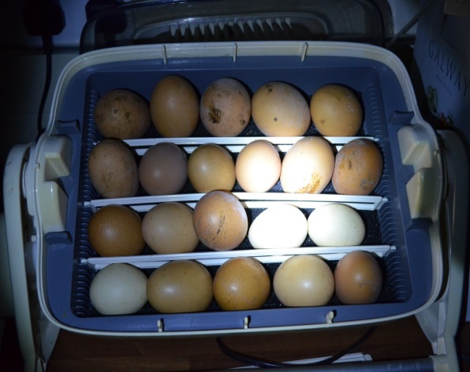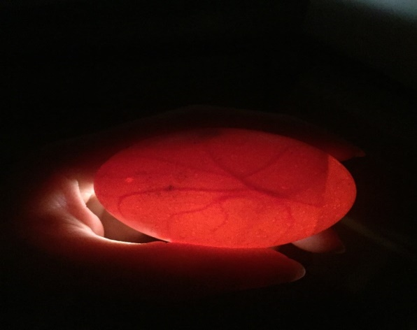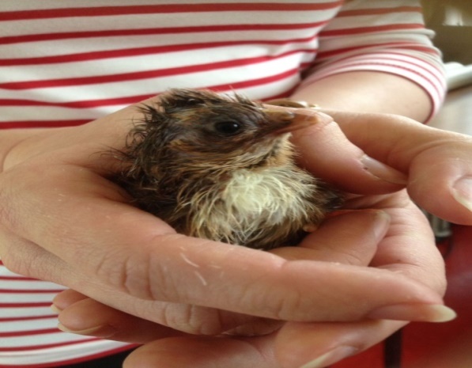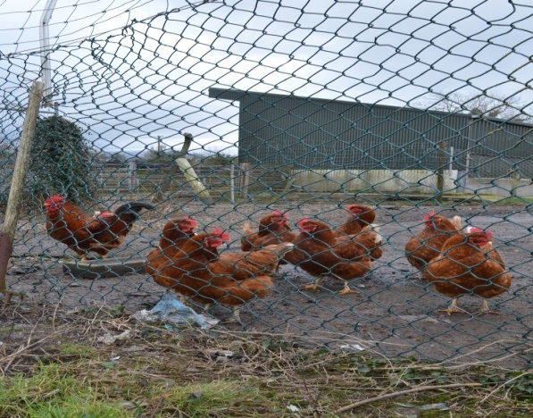

In Art Senior Infants created chicks hatching out of their eggs.
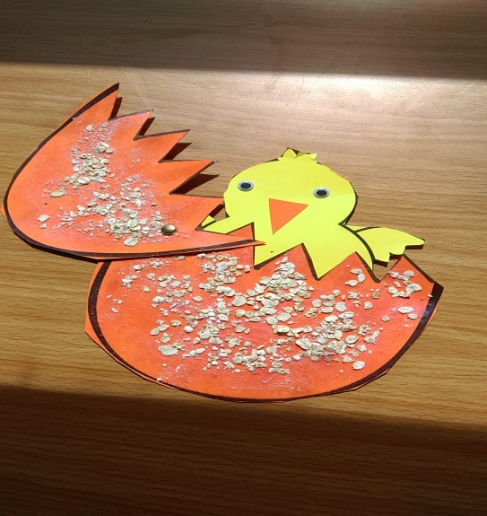

Senior Infants learned all about Panda bears in school. We learned that a baby panda is called a cub and that they like to eat bamboo. Here is evidence of their work.
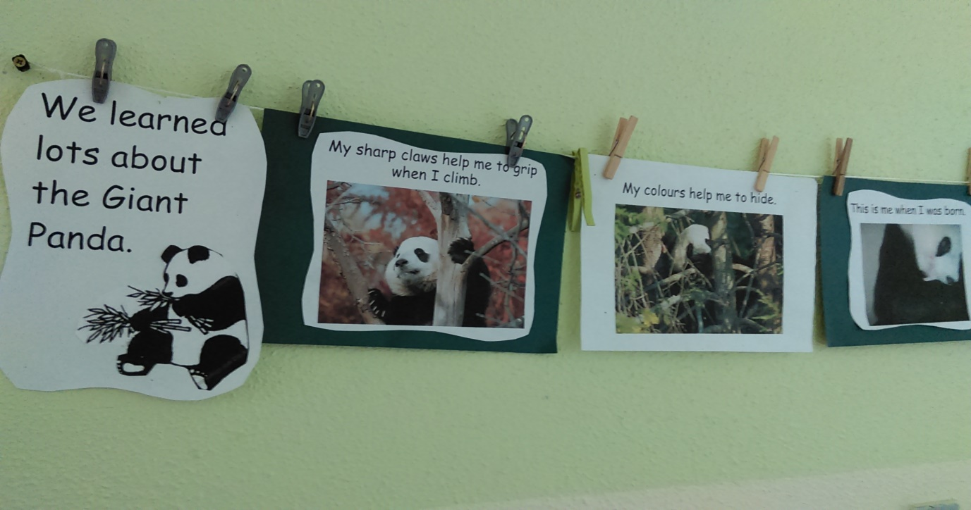
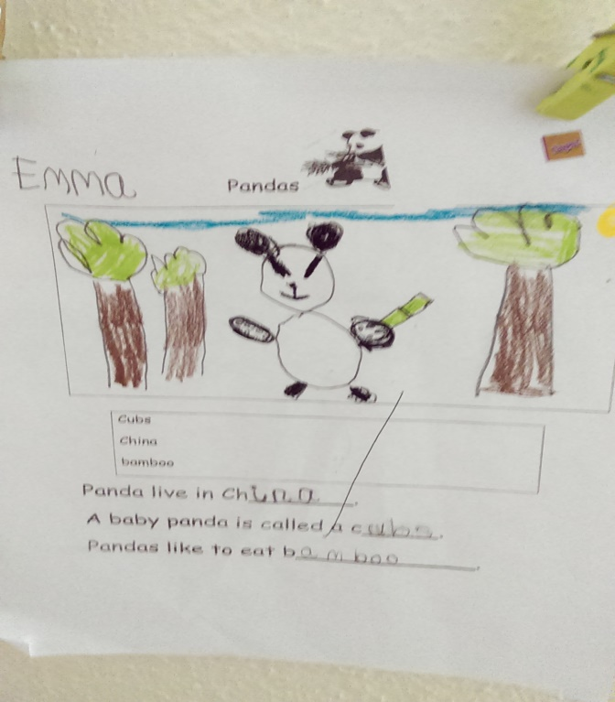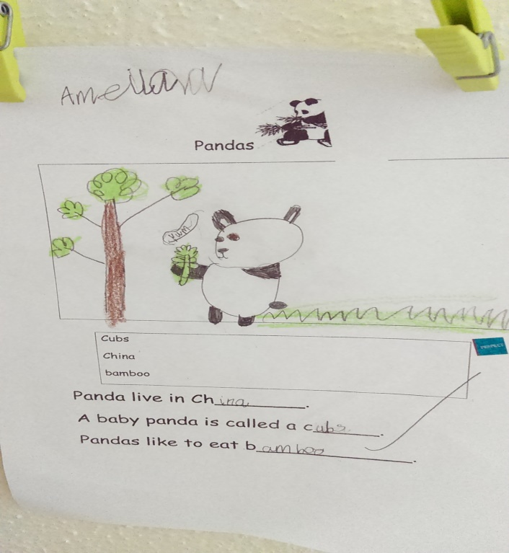

2) Energy and Forces x 2:
3rd Class : Light
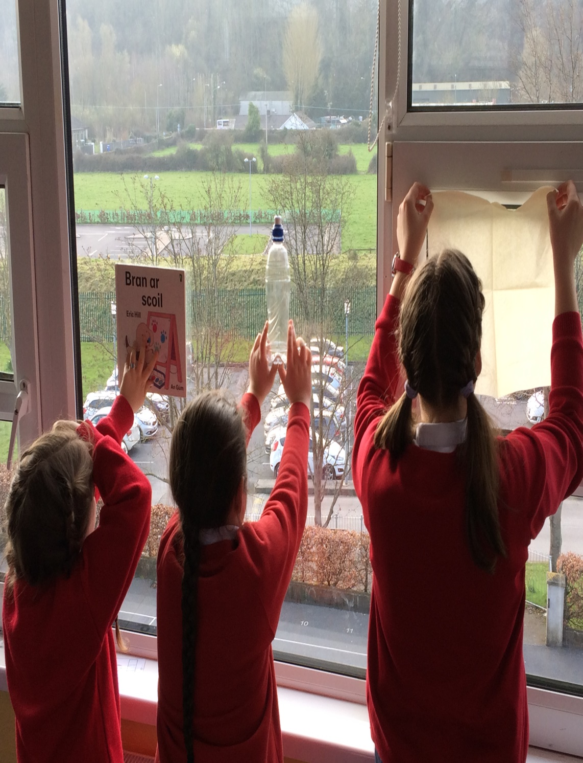
The class investigated the relationships between light and materials and recorded their findings here.
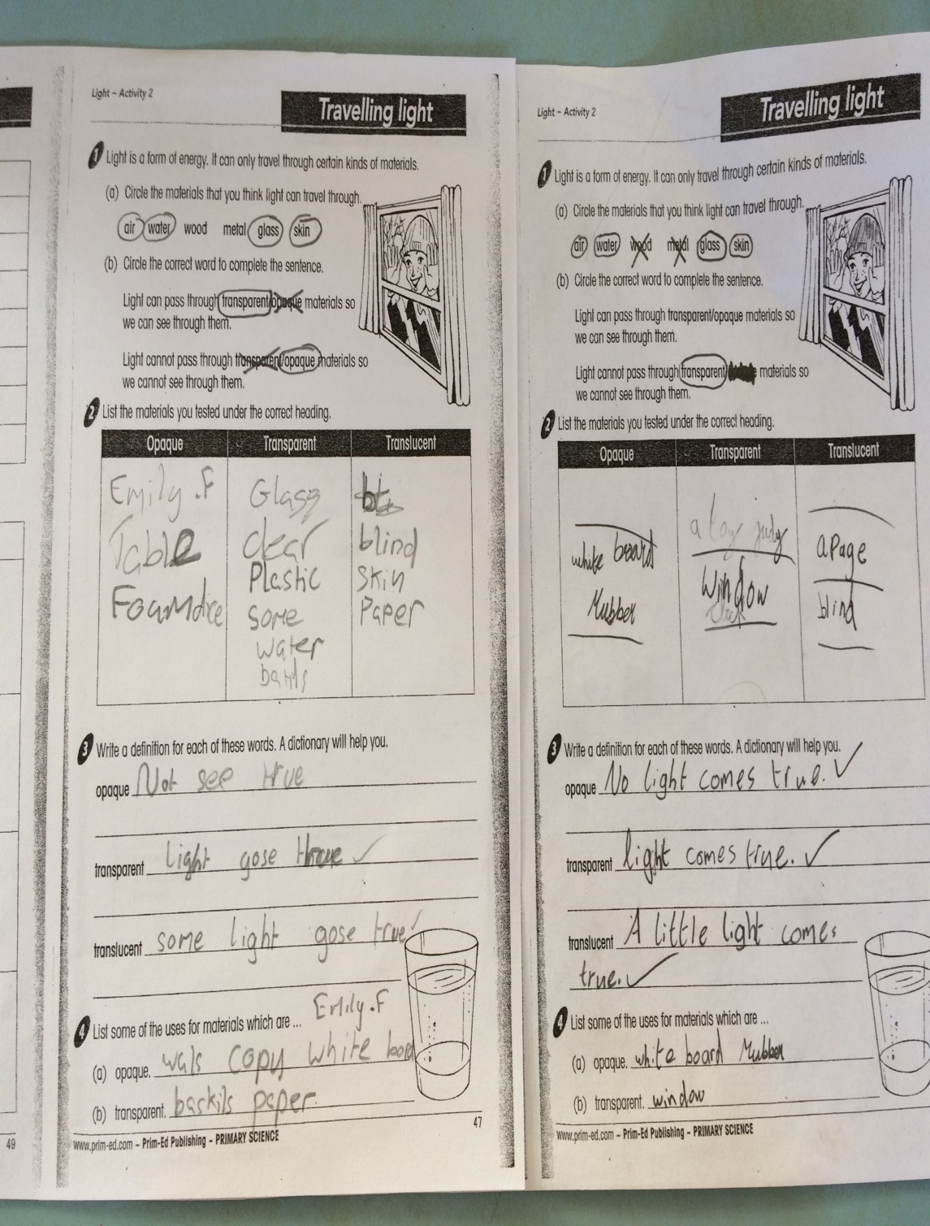
Science: Forces and Energy Strand - Pushing and Pulling.
For homework children in the speech and language classes had to find things in the house that needed to be pushed or pulled to make it work. Here they are pushing down on the springs.
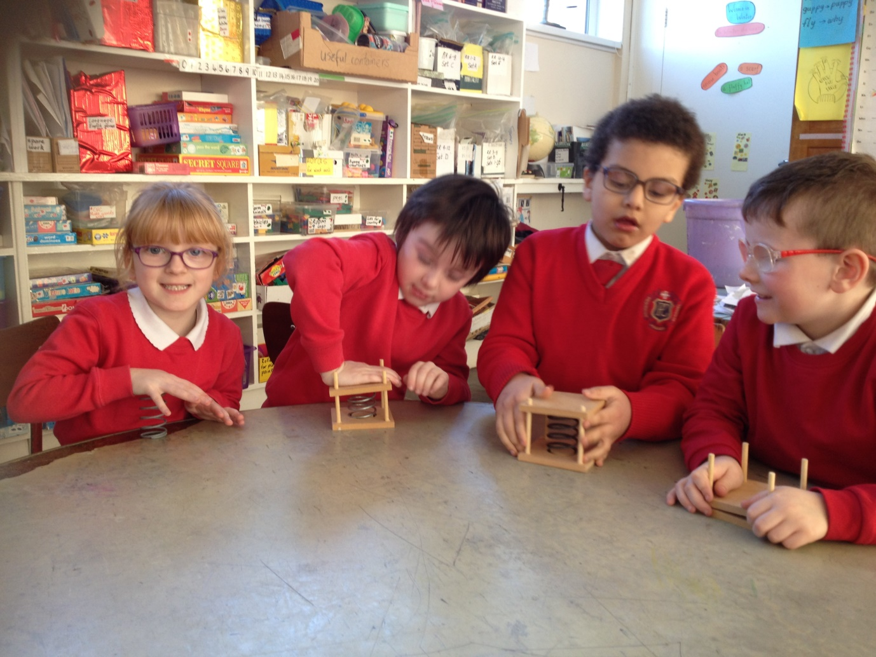

3) Materials x 2: Floating and Sinking - Speech and Language Classes
Science lesson : Predict if objects will float or sink.
Assessment: Hands on head for floating. Arms folded for sinking. What is your prediction?
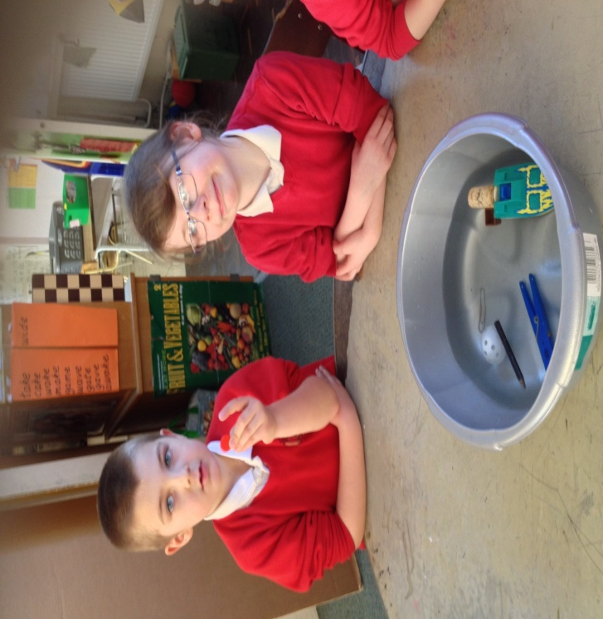
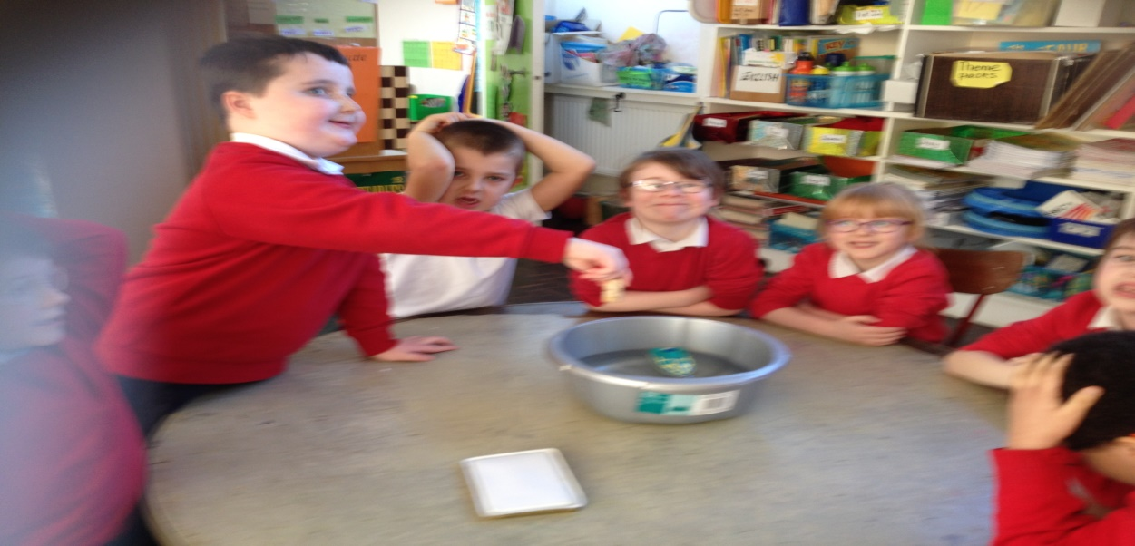

Materials lesson by 2nd Class
2nd Class investigated how materials change by making environmentally friendly playdoh.
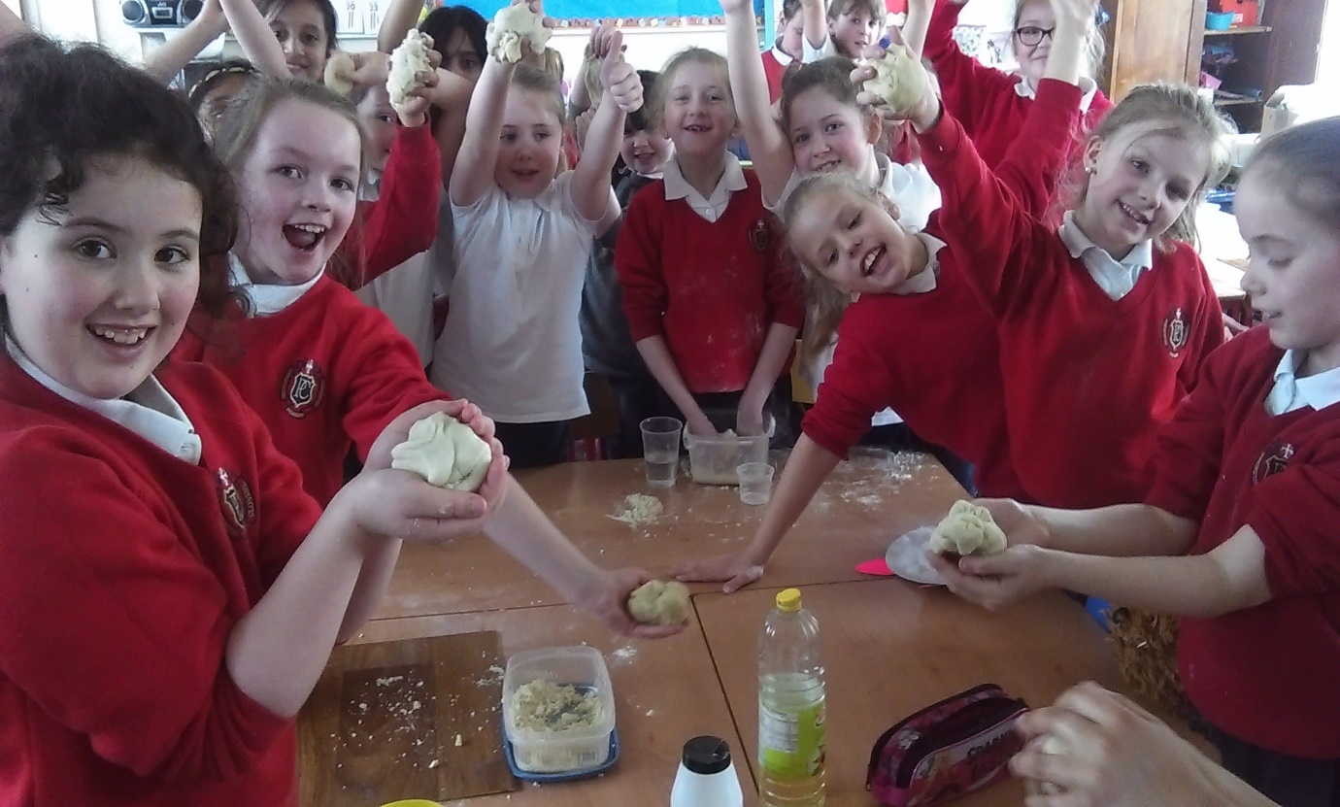

4) Environmental Awareness and Care x 1:
- Rang 6 took part in a project about all aspects of water this year – use of water, conservation of water, the problems and effects of water pollution on the environment, the different experiences of people around the world in relation to water etc. We experimented with different materials to learn how best to filter water.
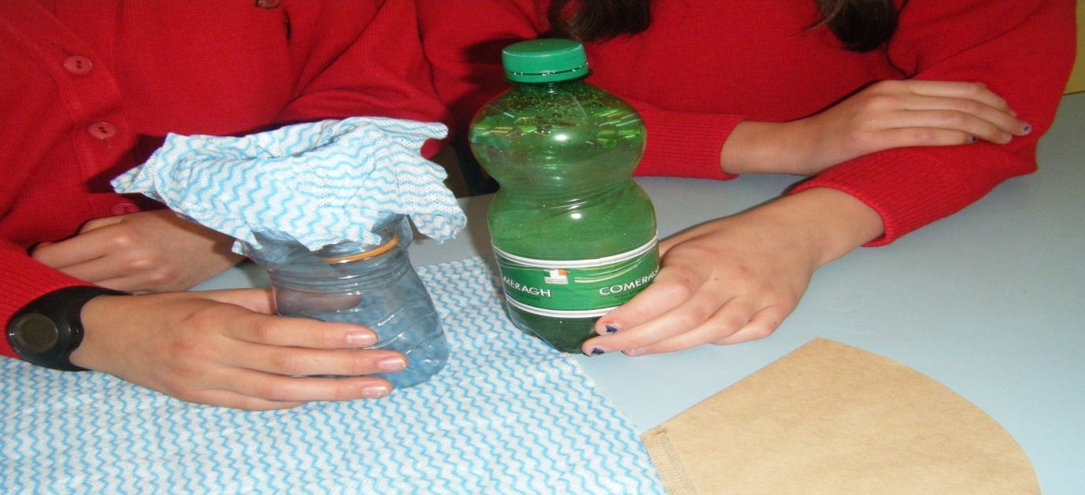
- Rang 6 learned about damp, its effects, how it can be removed and how people can prevent it from entering buildings etc. The photo shows one of our experiments.
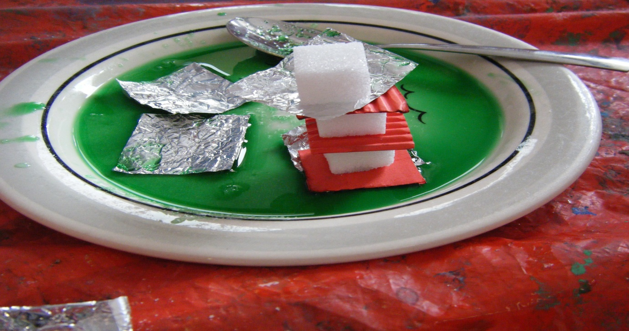

Science Event
Rang 5 agus Rang 6 attended a science show hosted by the Juggling Scientist (James Soper). Thank you to the Presentation Secondary School and Waterford Institute of Technology for providing this great show. We include two photos to give you an idea of what we learned! Check out the Juggling Scientist website that we researched. https://www.thejugglingscientist.com/
1. Oh dear! Unlike poles attract each other. It is difficult to pull these two magnets apart.
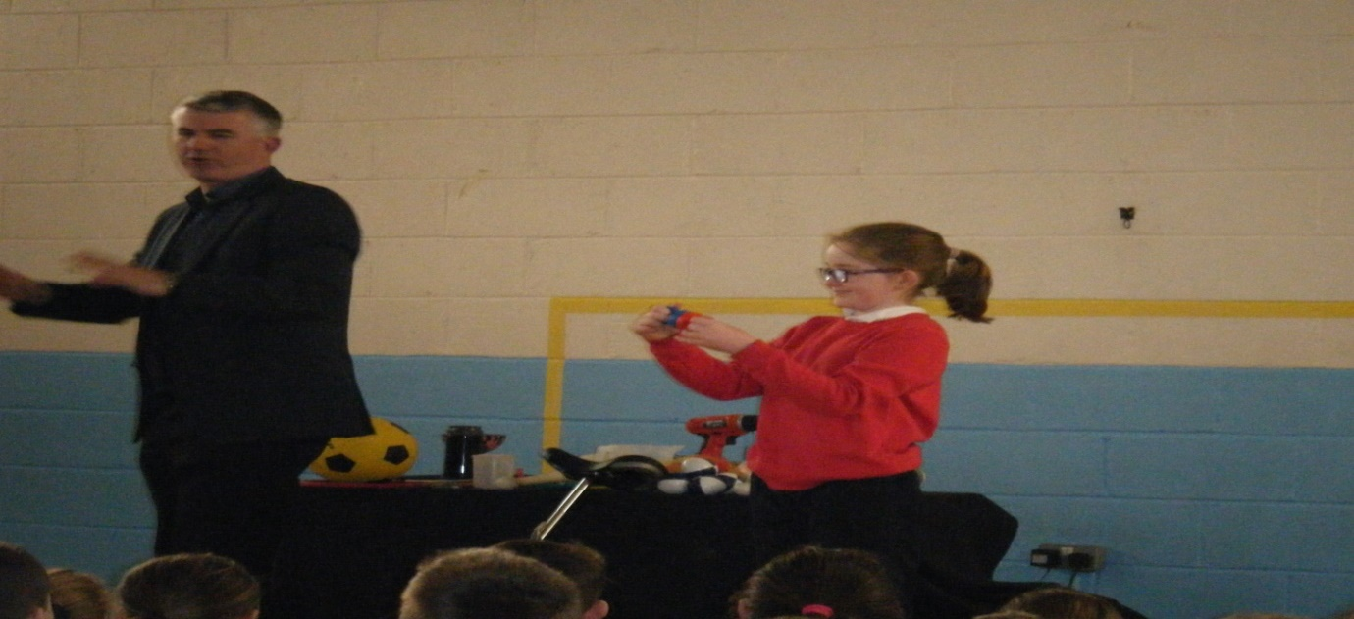
2. According to Newton’s First Law of Motion, objects in motion tend to remain in motion unless acted upon by an external force. Still we wondered if Mrs. Russell would spill the water. She didn’t!
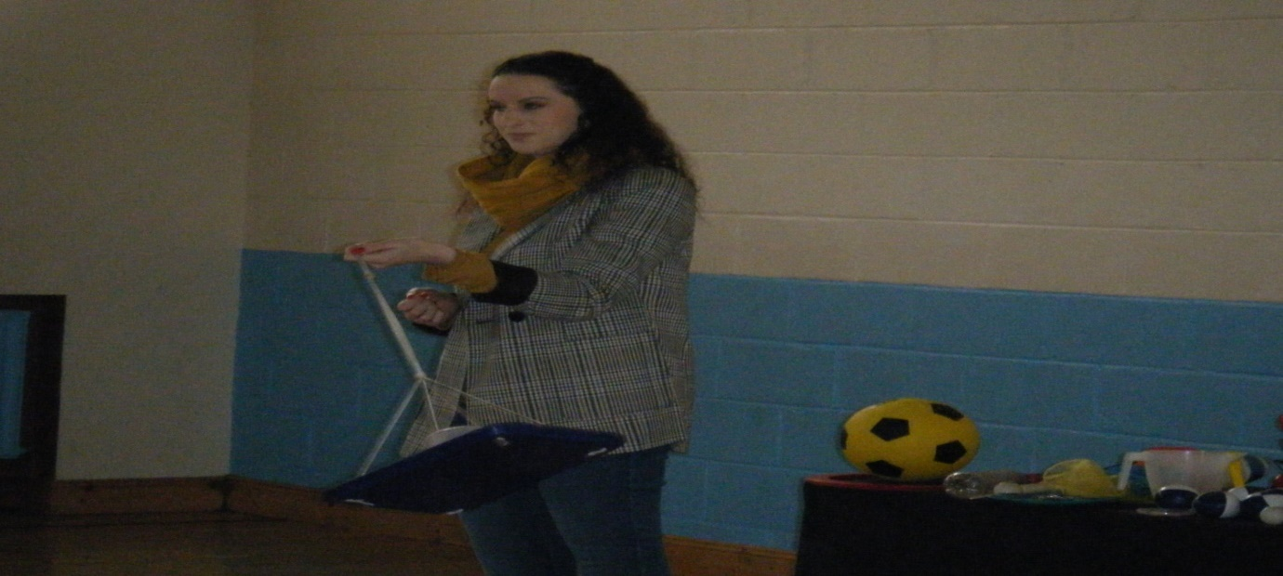

Step 2 Technology (ICT)
DPSM PLAQUE OF STEM EXCELLENCE 2 or more examples of the children using ICT The following are some examples of ICT:
- Evidence of the students developing coding and stories using the Scratch programme.
- Used computers for classwork (for any subject)
- Blogging and uploading photos to the ‘Kids Blog’ section of the school website.
1) 6th Class followed the Scratch programme with Ms. Mulcahy our computer and IT co-ordinator. We enjoyed creating stories about water and rain fall.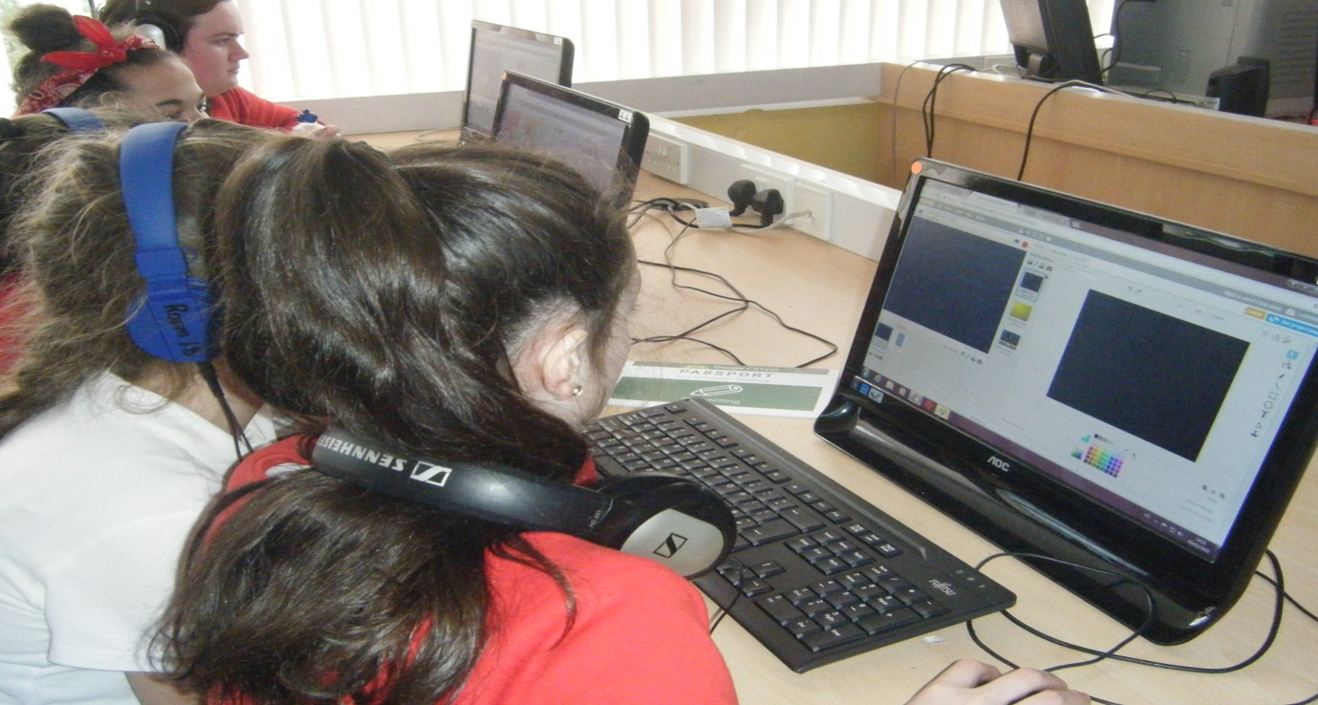
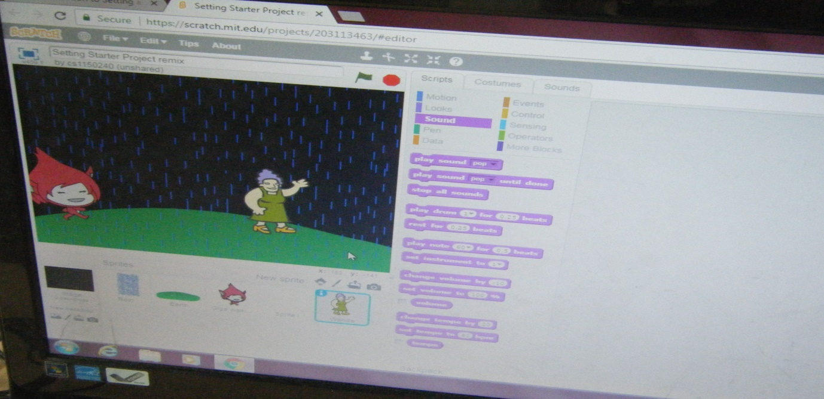

6th Class used technology to access a range of computer science information.We watched videos on the computer to learn how computer science is used to build many types of projects.
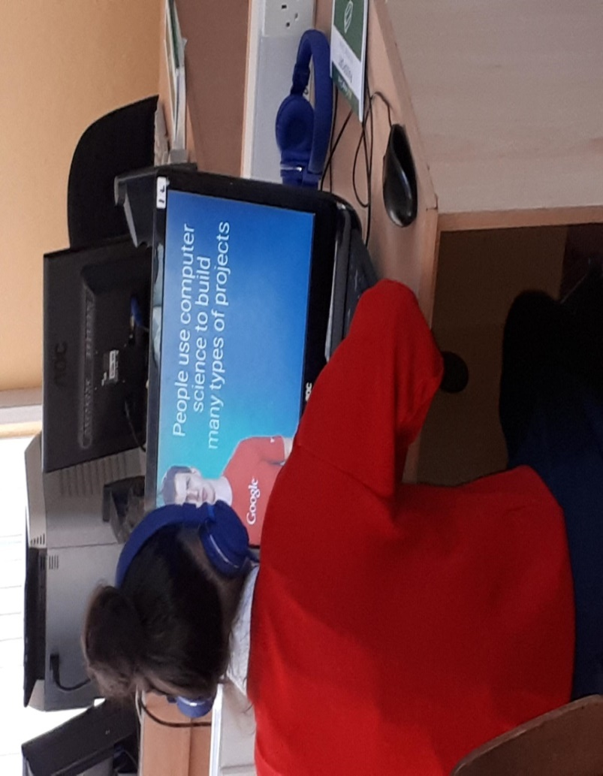
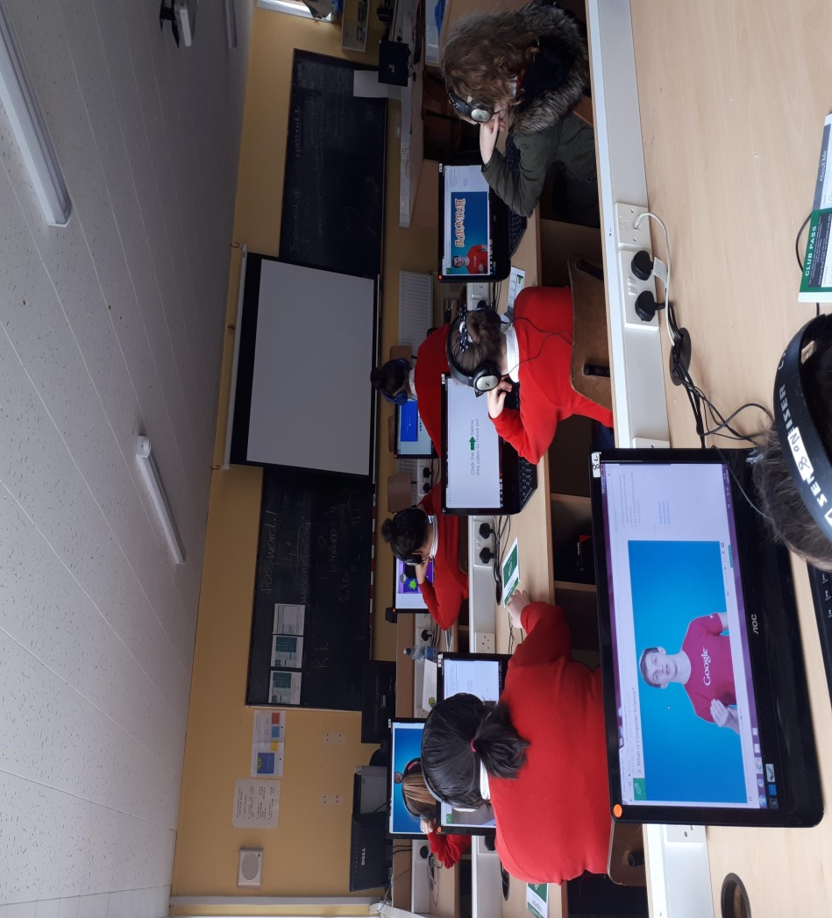

2) In our school this year every classroom was assigned two new computers.
These computers are used for every subject eg, Irish, Science, Maths, English and projects. Children work in pairs or independently using these computers throughout the school day. Here are 5th Class pupils publishing a piece of creative writing.
The girls uploaded it to the ‘Kids Blog’ section of the website. Check it out here :
https://www.presprimaryclonmel.com/kids-blog/a-long-way-from-home
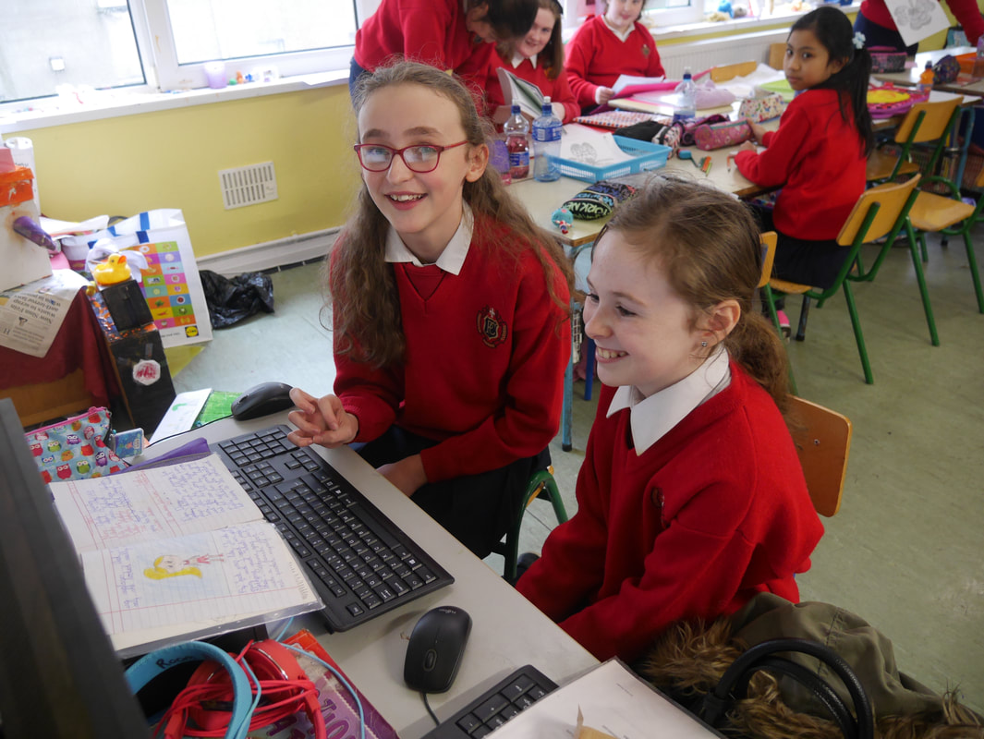

Step 3 Engineering
DPSM PLAQUE OF STEM EXCELLENCE
2 or more examples of the children investigating engineering in class or in the local area.The following are some examples of Engineering:
1 : Engineering – Great Wall of China : Construct a model.
2 : Engineering – Investigating engineering of houses and businesses in the local area.
1) Senior Infants and Speech and Language Classes built the ‘Great Wall of China.’

The children studied China and how the ‘Great Wall of China’

was built for Multi-Cultural Day and Aistear.

They designed their own model of the ‘Great Wall of China.’

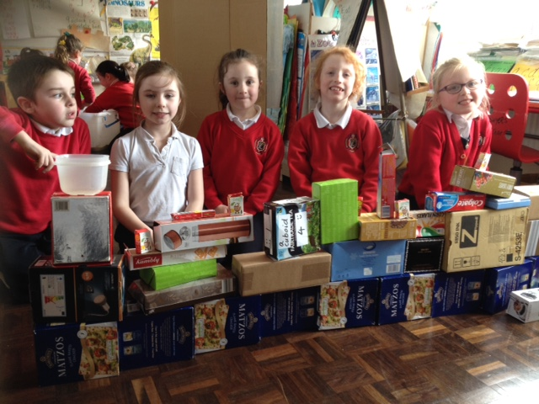

2) Mrs. Skehan’s speech and language class investigated the engineering of houses in the local area of Clonmel eg, caravans, terraced houses, bungalows, cottages etc. The group researched some local businesses eg, the Garda Station, Bulmers, Abbott Factory and Tesco. Check out their findings. The group also constructed and built their own house out of recycled materials.

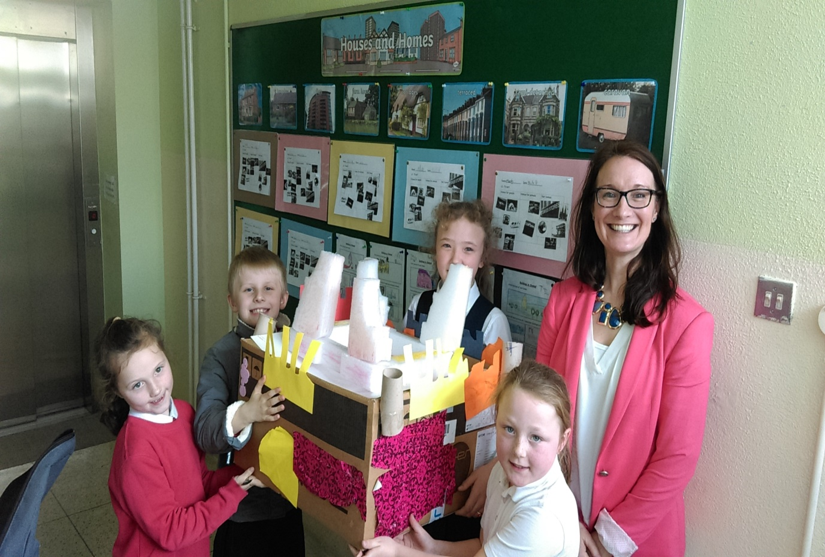

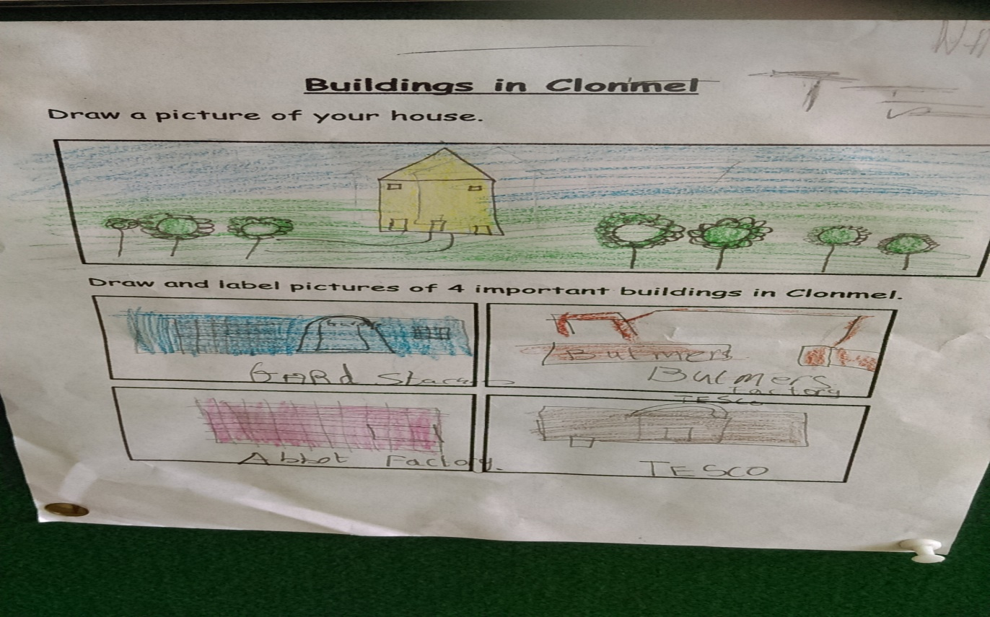

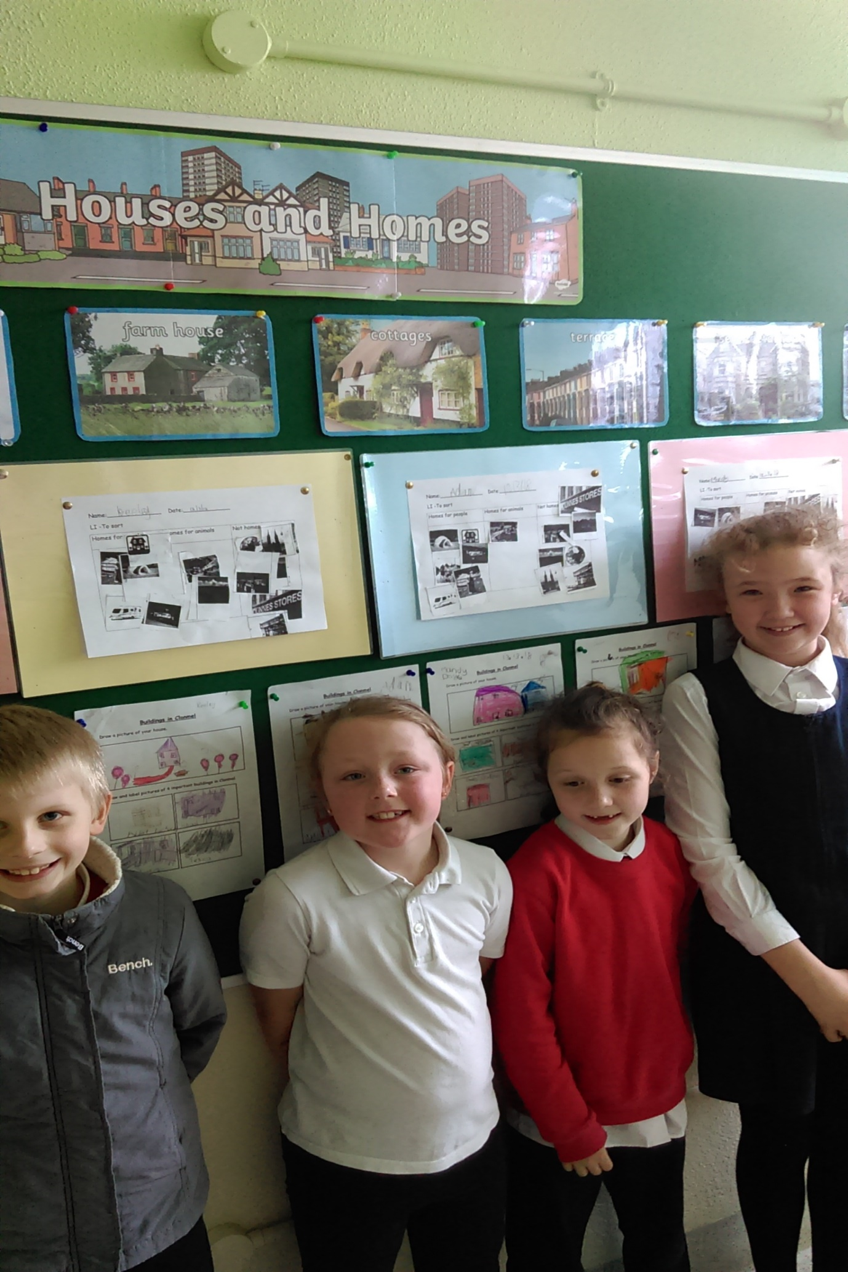

Step 4 Maths

DPSM PLAQUE OF STEM EXCELLENCE 2 or more examples of the children using their maths skills as part of their science work. The following are some examples of Maths:
- Using maths skills and knowledge as part of science e.g. measuring distances, capacity, weight, recording and analysing data. Using maths operations; ratio, percentages, averages. Activities can be found here
- 3rd Class grouped materials according to their properties and linked maths into these lessons.
- Adding of materials around the classroom eg, wood, glass, plastic, cloth, paper and metal.
- Recording of results by completing a bar graph.
- Analysing data by answering questions based on the bar graph.
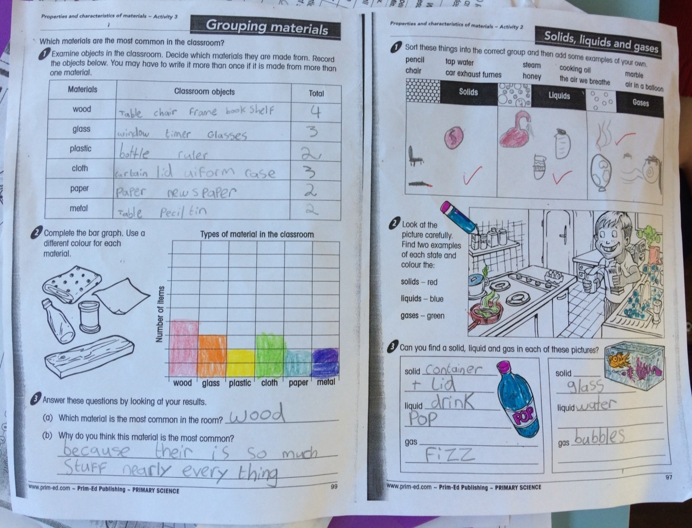

2) Speech and Language classes linked their science and maths learning.
Energy and forces was the strand being taught and the lesson was exploring pushing and pulling items.
The children investigated which object is the heaviest? How do you know? What happened to the spring when you hooked on the object?
The children found heavier and lighter objects around the classroom and compared their weights.
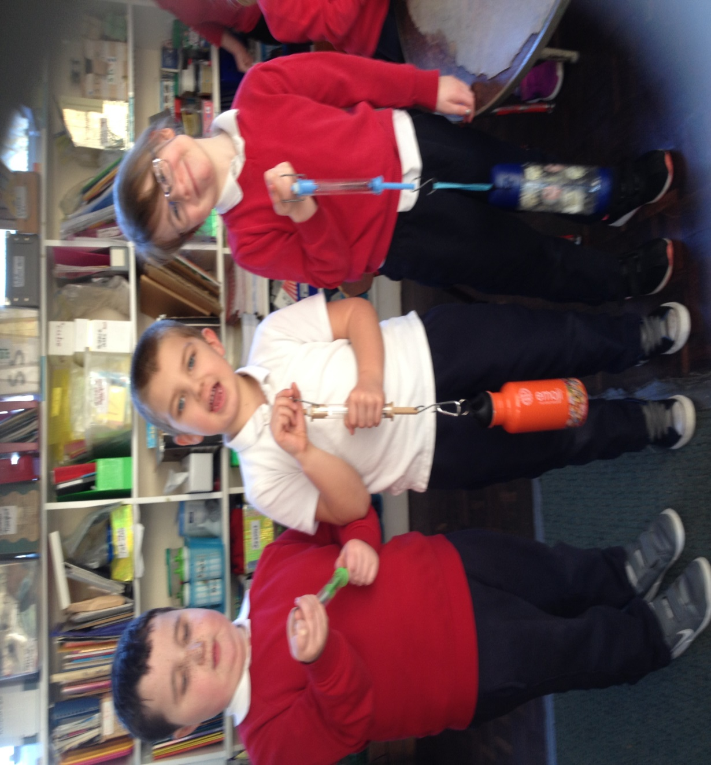
3) Rang 6 combined the use of Maths and Science when they learned about insulation. We used thermometers to check the falling temperature of the water in containers that were surrounded by various insulators.
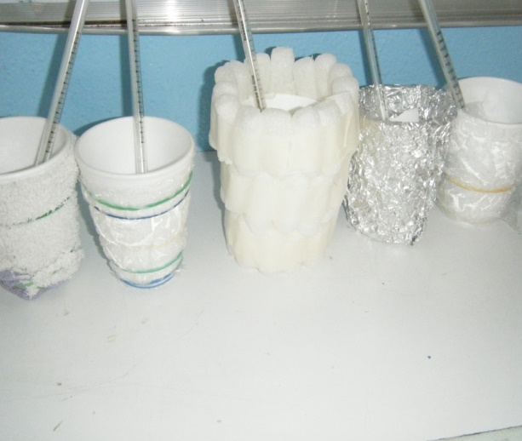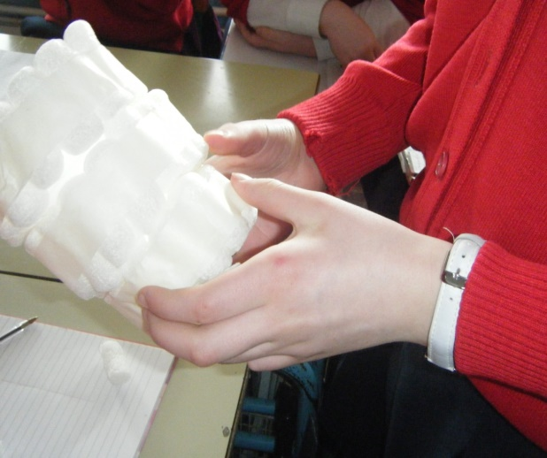
We used the data to work out the best insulator and the least effective insulator in each group. We did follow-on Maths work about the cost of insulating houses, the reduction in heat loss and how long it would take until the homeowner would start saving money.
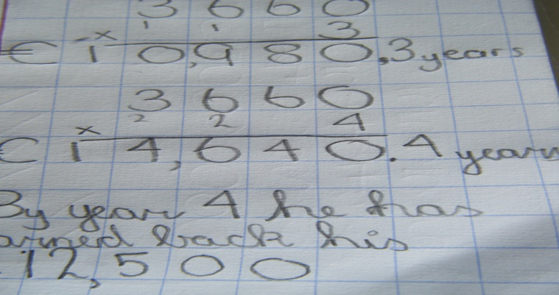
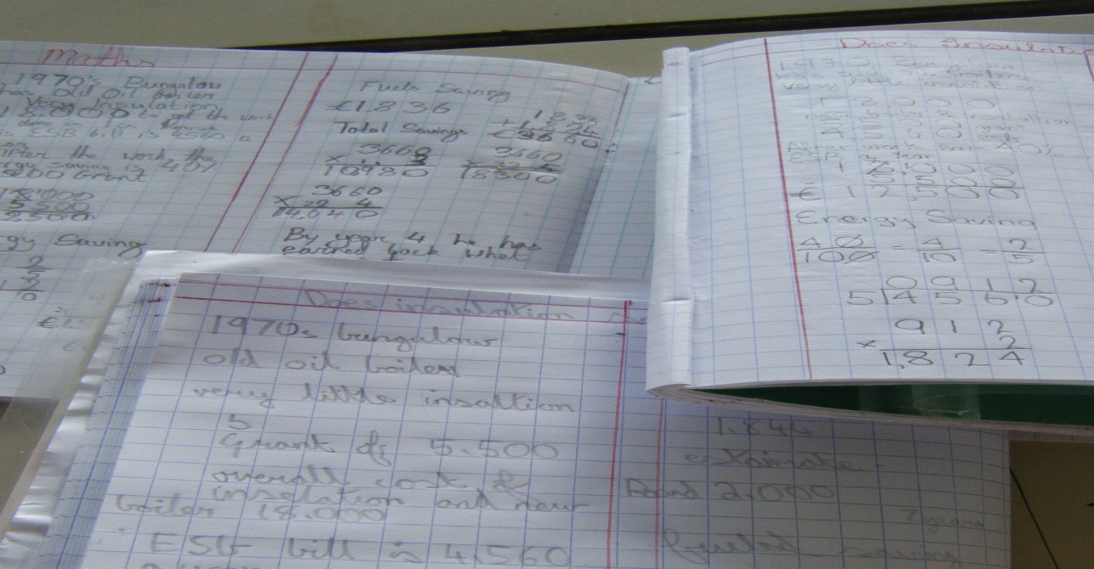
Step 5 Stem Showcase DPSM PLAQUE OF STEM EXCELLENCE Choose one or more of the following: 1) Have a science display in the school or present work to other classes.
  - Presenting science to another class.
3rd Class presented their science work to Junior Infants. Both classes did interactive hands on experiments exploring the strand of ‘Energy and Forces.’ They investigated falling objects and showed the Junior Infants at the top of the class. 3rd Class then worked with the Junior Infant children in pairs and the children were at different heights on the chairs dropping items.
